Careerr-related Programme LInks

PPS- Washington County folder (shared with us- Thank you Chris and Kim)https://drive.google.com/drive/folders/1hjrBy4BscP7mE5QBVZs_2yZ4_sLJfJ19?usp=drive_link

https://drive.google.com/drive/folders/1YkYwsfXYEzGYPRvc0bm0IweH3SxTujYl?usp=drive_link

PPS- To be clear, we are not ashamed to say that we have pilfered ideas and documents from other schools online. If you recognize something that was your schools, thank you for sharing 😉

Language Development- https://drive.google.com/drive/folders/1Vubk8Zw-nCdaoJ6-e3WaU_CLBPO0Wu4d?usp=drive_link

https://drive.google.com/drive/folders/1vGRpIpyP58btpHRR4RfoSVDfw5JpoMLx?usp=drive_link

https://drive.google.com/drive/folders/1pvgsmaCEMtT6o3GI5DMssdSFkY6eUEa2?usp=drive_link

https://docs.google.com/document/d/1ZgtWif9OXveuy2u7Jk-_I1FLHbS8HK7R/edit?usp=sharing&ouid=112162829052041452298&rtpof=true&sd=true

Lang- samples- https://drive.google.com/drive/folders/160atF7Y3BWxw1Ig1NZHvQHSDG9I2st7a?usp=sharing

Portfolios
https://drive.google.com/drive/folders/18U8rC8v6xBov0b9XY5n2iU9NCGvtVoQZ?usp=sharing

Reflective Proj. samples
https://drive.google.com/drive/folders/170lJXn3ndUaW-psojDrG9GNXqvCbJ87p?usp=sharing

Service Proj ideas
https://drive.google.com/drive/folders/1g5Wc909IsQ1717auivMwJLUAwFtMtb1Q?usp=sharing

Electronic notebook
https://docs.google.com/presentation/d/1TmYTDbJxGvsrCsTd62VgZKHdsuEs2L_pNRLWdJg_fBg/edit?usp=sharing
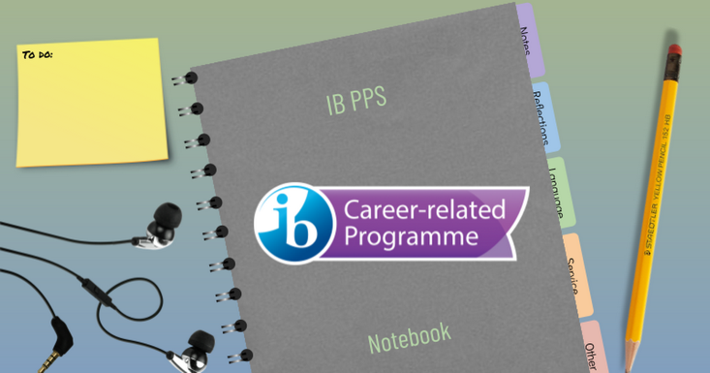 | Copy of PPS Notebook  Feel free to make a copy of this template for your own use. File -> Make a Copy. You can modify tabs, colors, and layouts by going to Slide -> Edit Master Please credit www.slidesmania.com for the spiral template and Isabel Morales @isabeljmorales for the page layouts. Thank you for keeping these...  docs.google.com
Reflective Project:
https://drive.google.com/drive/folders/18x9YC5FhmsZUniSD-k5wcFKog-JNwtu0?usp=drive_link

Service Learning:
https://drive.google.com/drive/folders/1uT_dswHPpVM68Q7bya29g910gQZUCcIx?usp=drive_link

CP Unit Planners
https://drive.google.com/drive/folders/1Ic4Jb8bO4N2KMddW796ppnPmJrcagOnR?usp=drive_link

Meade HS - https://drive.google.com/drive/folders/1zYGEBgYoMEh1TyEoanuyzZUb9LqChr1k?usp=drive_link

